How to run e1 report

Financial Reporting
Work Order Transaction Detail
Event Year - 001
Fiscal Year - 006
- Both EY and FY can be pulled simultaneously by checking both boxes

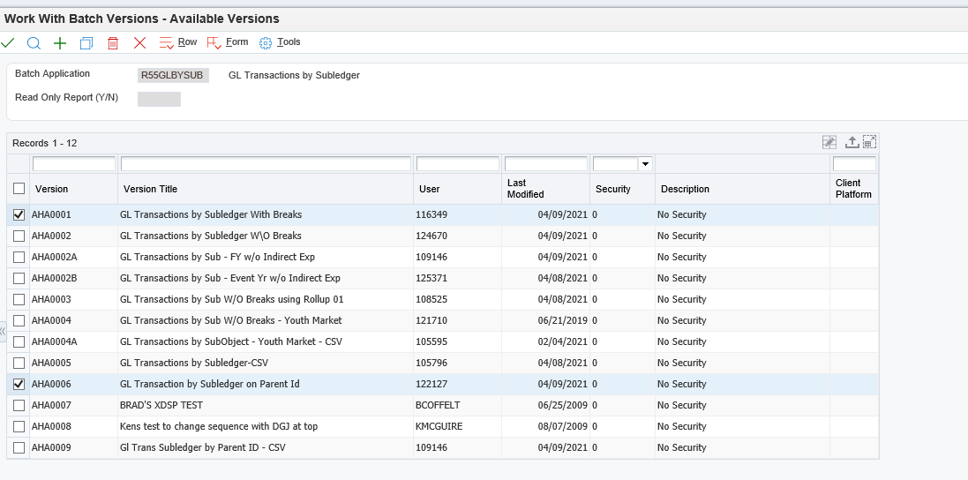

Hit the green checkmark
Data Selection then click submit

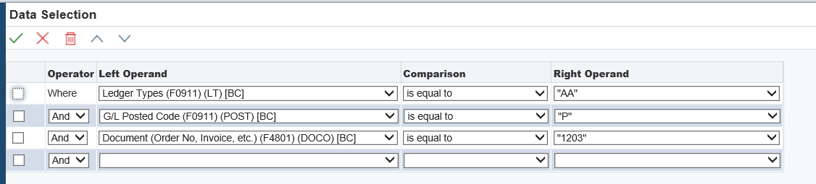

Change 1203 to "Literal" 73991

CODES: HB: 71519 (EY) or ES DC HB (FY) , WB:73936 (EY) or ES GWR WMNS BRD (FY),
4790 (expenses)

Literal Value - enter a code #

4th line that's blank - change to Object Account (F0911), less than or equal to, Literal -

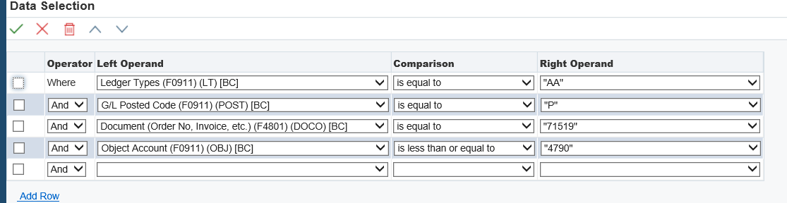

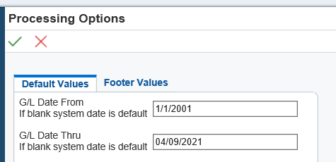

For Fiscal Year change above to FY dates, otherwise start at 1/1/2001

Click green checkmark on print page

How to interpret report
4615: Corporate Sponsorship; 4625: External platform (Event.Gives, Mobile Cause); 4635:Patron/Individual sponsorship 4605. Learn: OYH Donation; 4700s: expenses

