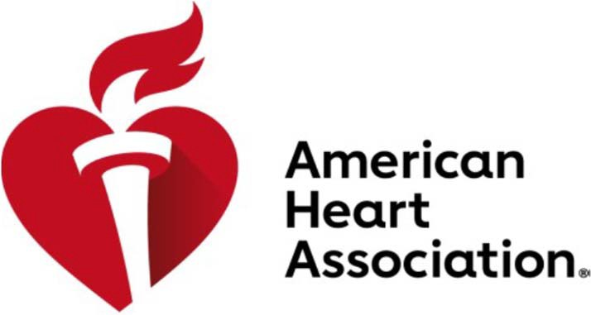

INVOICE / PLEDGE

Remit To:
American Heart Association
Eastern States – Accts. Rec.
PO Box 4002012
Des Moines, IA 50340-2012

Billing Address:
American Nonsmokers' Rights Foundation
Attn: Joseph Cadiz
2530 San Pablo Ave., Suite J Berkeley, CA 94702

AHA Tax ID: 13-5613797

Date: 04/29/2021
Customer #: 1281305
Page: 1

Customer Address:
American Nonsmokers' Rights Foundation
Attn: Joseph Cadiz
2530 San Pablo Ave., Suite J
Berkeley, CA 94702

Finance: 402230.4140.72840.72841

Invoice
Date Number Type Due Date Remark Amount
04/29/2021 999999 Invoice 05/29/2021 ES NY GRFW S22 Sponsorship $ 10,937.00

$ 10,937.00

PLEASE INCLUDE A COPY OF THIS INVOICE WITH YOUR PAYMENT. THANK YOU!

IF YOU HAVE ANY QUESTIONS, PLEASE CALL 214-706-1130.

